**Database specifications for EcoBike Application**

1. **ER-Diagram**

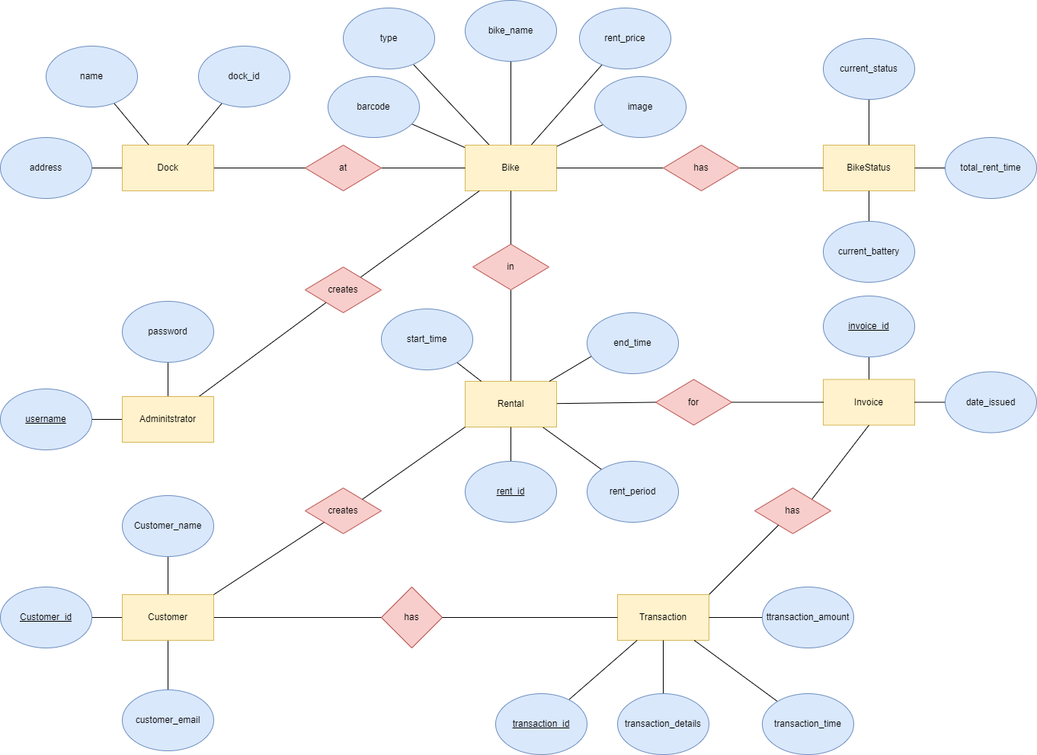

1. **Table specifications**

## **Administrator**

|  |  |  |  |  |  |  |
| --- | --- | --- | --- | --- | --- | --- |
| **No.** | **PK** | **FK** | **Name** | **Data type** | **Mandatory** | **Description** |
| 1 | x | x | username | varchar(256) | x | Username of the administrator |
| 2 |  |  | password | varchar(256) | x | Password of the administrator used to login |

## **Dock**

|  |  |  |  |  |  |  |
| --- | --- | --- | --- | --- | --- | --- |
| **No.** | **PK** | **FK** | **Name** | **Data type** | **Mandatory** | **Description** |
| 1 | x | x | dock_id | int | x | ID of dock |
| 2 |  |  | dock_name | varchar(256) | x | Name of the dock |
| 3 |  |  | dock_address | varchar(256) | x | Address of the dock |
| 4 |  |  | dock_area | float |  | Area of the dock |
| 5 |  |  | num_available_bike | int | x | Number of current available bike in dock |
| 6 |  |  | num_free_dock | int | x | Number of current available bike slot in dock for returning bike |

## **Bike**

|  |  |  |  |  |  |  |
| --- | --- | --- | --- | --- | --- | --- |
| **No.** | **PK** | **FK** | **Name** | **Data type** | **Mandatory** | **Description** |
| 1 |  |  | bike_name | varchar(256) | x | Name of the bike |
| 2 |  |  | bike_type | varchar(16) | x | Type of bike |
| 4 |  |  | bike_image | varchar(256) |  | Path to image of the bike |
| 5 | x | x | bike_barcode | int | x | Barcode of the bike |
| 6 |  |  | bike_rental_price | float | x | Price to rent the bike |
| 7 |  |  | deposit_price | float | x | Deposit cost to rent the bike |

## **Bike in dock**

|  |  |  |  |  |  |  |
| --- | --- | --- | --- | --- | --- | --- |
| **No.** | **PK** | **FK** | **Name** | **Data type** | **Mandatory** | **Description** |
| 1 |  |  | dock_id | int | x | Id of the dock |
| 2 |  |  | bike_barcode | int | x | Barcode of the bike in dock |

## **Bike status**

|  |  |  |  |  |  |  |
| --- | --- | --- | --- | --- | --- | --- |
| **No.** | **PK** | **FK** | **Name** | **Data type** | **Mandatory** | **Description** |
| 1 |  |  | bike_barcode | int | x | Barcode of the bike |
| 2 |  |  | current_status | varchar(4) | x | ‘free’/’rent’ |
| 3 |  |  | total_rent_time | int | x | Total time that the bike is rented (in minute) |
| 4 |  |  | current battery | float | x | Current battery status of the bike |

1. **Transaction**

|  |  |  |  |  |  |  |
| --- | --- | --- | --- | --- | --- | --- |
| **No.** | **PK** | **FK** | **Name** | **Data type** | **Mandatory** | **Description** |
| 1 | x |  | transaction_id | int | x | ID of transaction |
| 2 |  |  | transaction_amount | int | x | The amount of money for the transaction |
| 3 |  |  | transaction_time | String | x | Time the transaction is made |
| 4 |  |  | transaction_details | varchar(256) |  | The content of the transaction |
| 5 |  | x | creditcard_number | int | x | The number of the credit card |

## **Rental**

|  |  |  |  |  |  |  |
| --- | --- | --- | --- | --- | --- | --- |
| **No.** | **PK** | **FK** | **Name** | **Data type** | **Mandatory** | **Description** |
| 1 |  |  | bike_barcode | int | x | Barcode of the bike being rented |
| 2 |  |  | start_time | time | x | Time start renting |
| 3 |  |  | end_time | time |  | Time end renting (null if the bike is currently being rented) |
| 4 |  |  | rent_period | int |  | Total time renting the bike, in terms of minutes (null if the bike is currently being rented) |
| 5 | x |  | rent_id | int |  | ID of the rental |

## **Invoice**

|  |  |  |  |  |  |  |
| --- | --- | --- | --- | --- | --- | --- |
| **No.** | **PK** | **FK** | **Name** | **Data type** | **Mandatory** | **Description** |
| 1 | x |  | invoice_id | int | x | ID of the invoice |
| 2 | x |  | transaction_id | int | x | Id of the transaction related to the invoice |
| 3 | x |  | rent_id | int |  | ID of the rental |
| 4 |  |  | date_issued | String |  | String representation of the date that the invoice is issued |

1. **Customer**

|  |  |  |  |  |  |  |
| --- | --- | --- | --- | --- | --- | --- |
| **No.** | **PK** | **FK** | **Name** | **Data type** | **Mandatory** | **Description** |
| 1 | x |  | customer_id | int | X | ID of the customer |
| 2 |  | x | Customer_name | varchar(256) | x | Name of the customer |
| 3 |  | x | customer_email | varchar(256) |  | Email of the customer |